**Budapest---Veinna---Prague----Lake Balaton or Esztergom + Szentendre----Gyor**

**We need to:**

* **purchase Eurail passes for 3 countries: $220 for youth**
* **book hotel for Vienna: I need your help to decide where to stay**
* **book hotel for Prague OR stay at our apartment**

**Day 1, Thursday, 28th July: Budapest**

Welcome to Budapest, a city split down the middle by the Danube River into two towns, each complete with its own distinct personality. You'll find rolling hills, historic Ottoman relics and the famous Castle District in Buda, whereas flat Pest is marked by wide, tree-lined boulevards, crumbling apartment blocks and trendy ruin-style bars. Budapest is a city that merits a longer visit, but if you're just here on a flyover, follow my guide to the must-see places.

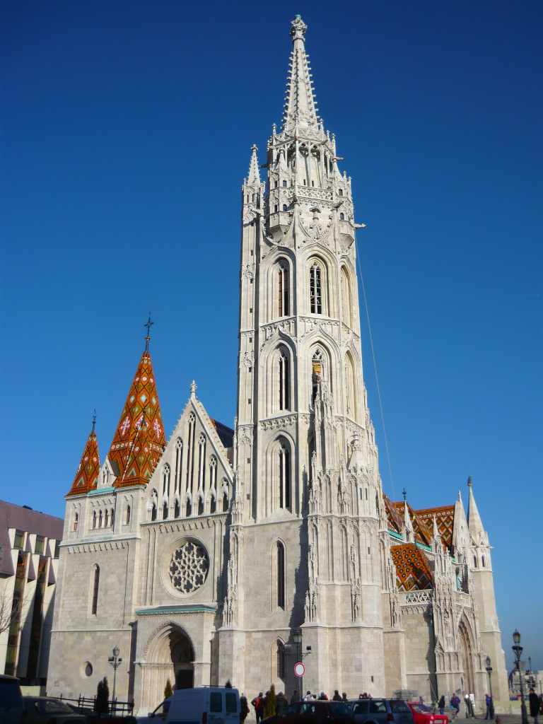Cited as one of the most beautiful cities in [Europe](https://en.wikipedia.org/wiki/Europe), Budapest's extensive [World Heritage Site](https://en.wikipedia.org/wiki/World_Heritage_Site) includes the banks of the [Danube](https://en.wikipedia.org/wiki/Danube), the [Buda Castle](https://en.wikipedia.org/wiki/Buda_Castle) Quarter, [Andrássy Avenue](https://en.wikipedia.org/wiki/Andr%C3%A1ssy_Avenue), [Heroes' Square](https://en.wikipedia.org/wiki/H%C5%91s%C3%B6k_tere) and the [Millennium Underground Railway](https://en.wikipedia.org/wiki/Line_1_%28Budapest_Metro%29), the second-oldest [metro line](https://en.wikipedia.org/wiki/Rapid_transit) in the world. It has around 80 geothermal [springs](https://en.wikipedia.org/wiki/Sz%C3%A9chenyi_Medicinal_Bath), the world's largest thermal water cave system, second largest [synagogue](https://en.wikipedia.org/wiki/Doh%C3%A1ny_Street_Synagogue), and third largest [Parliament](https://en.wikipedia.org/wiki/Hungarian_Parliament_Building) building. The city attracts about 4.4 million tourists a year, making it the 25th most popular city in the world, and the 6th in [Europe](https://en.wikipedia.org/wiki/Europe), according to [Euromonitor](https://en.wikipedia.org/wiki/Euromonitor).

* Arrive at Liszt Ferenc Airport 10:55p.m.
* Rest

**Day 2, Friday 29th July: Budapest**

**9 AM – 12 AM:**

**Breakfast:** at home

15 minute drive

* **Castle Hill,** on a bucolic plateau above Buda, is an evocative tangle of cobblestone streets and gothic houses. It's worth spending a day here, especially to visit Buda Castle.
  + **Matyas Templom (Matthias Church)**
  + **Halaszbastya (Fisherman’s Bastion)**

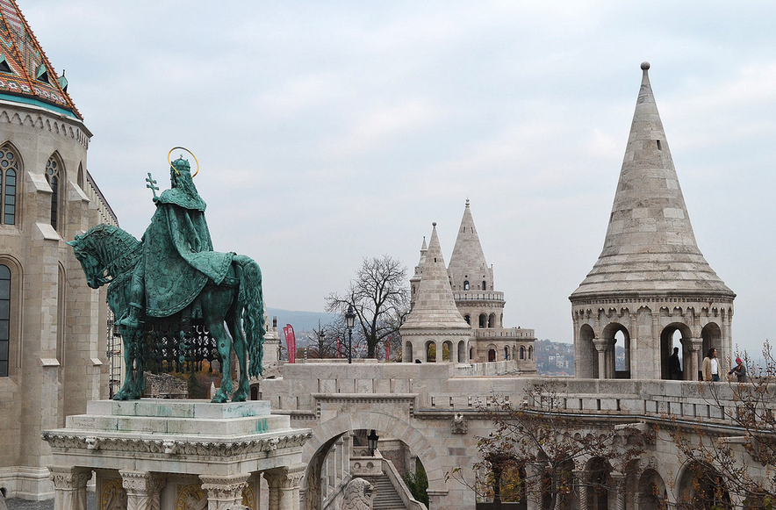

12 minutes walk

* + **Hungarian National Gallery**

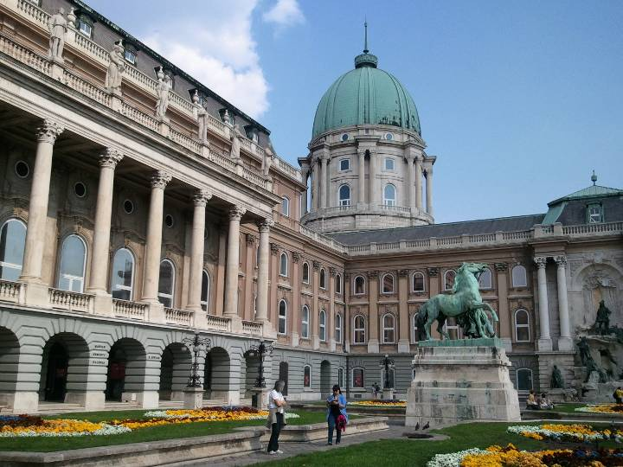

**12 AM – 2PM:**

12 minute walk down the Buda Hill to **Szechenyi Lanchid (Chain Bridge)**

Walk across Szechenyi Lanchid (Chain Bridge)-srrive at Szent Istvan park and walk to

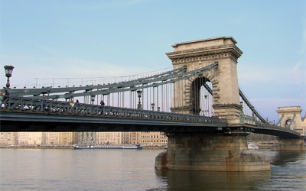

13 minutes walk to:

* **Shoes on the Danube**

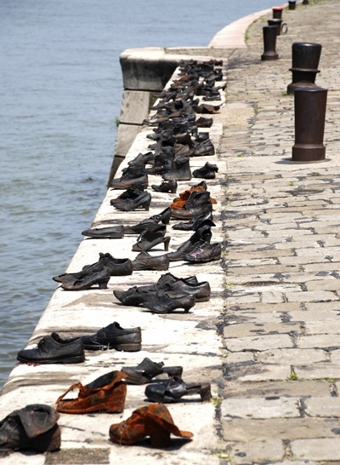

7 minutes walk to:

* **Parliament**

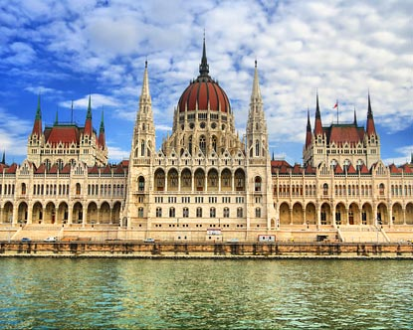

7 minutes walk to:

* **Szabadsag ter**

6 minutes walk to:

* **Gelarto Rosa-Ice Cream shop (rose-shaped ice cream, yummy ☺)**

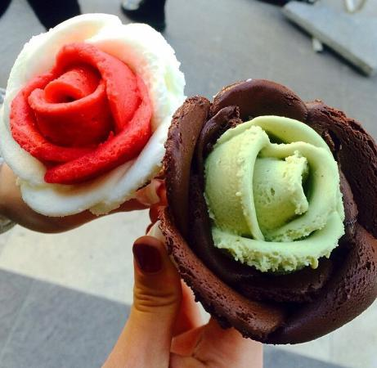

7 minutes walk to:

* **Szent Istvan Bazilika**

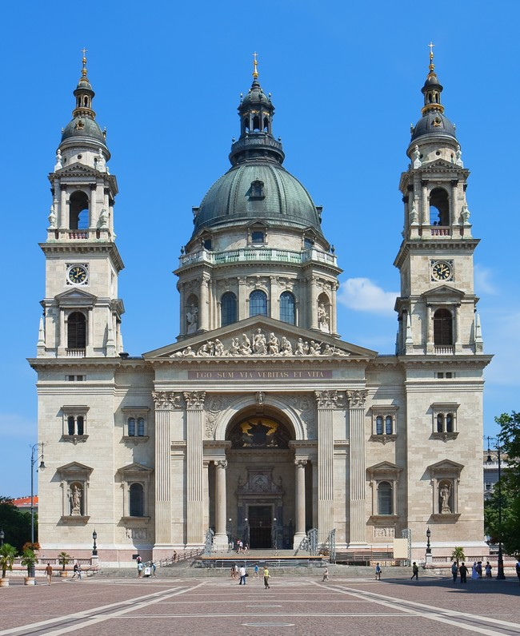

* A stroll along **Andrássy út** will bring into focus exactly why Budapest was the co-capital of the Austro-Hungarian Empire. Beneath your feet is the continent's first underground railway, and lining the avenue is the [Opera House](http://www.fodors.com/world/europe/hungary/budapest/review-142028.html) and the [Museum of Fine Arts](http://www.fodors.com/world/europe/hungary/budapest/review-90599.html).

5 minutes walk to:

* + **Hungarian State Opera House**

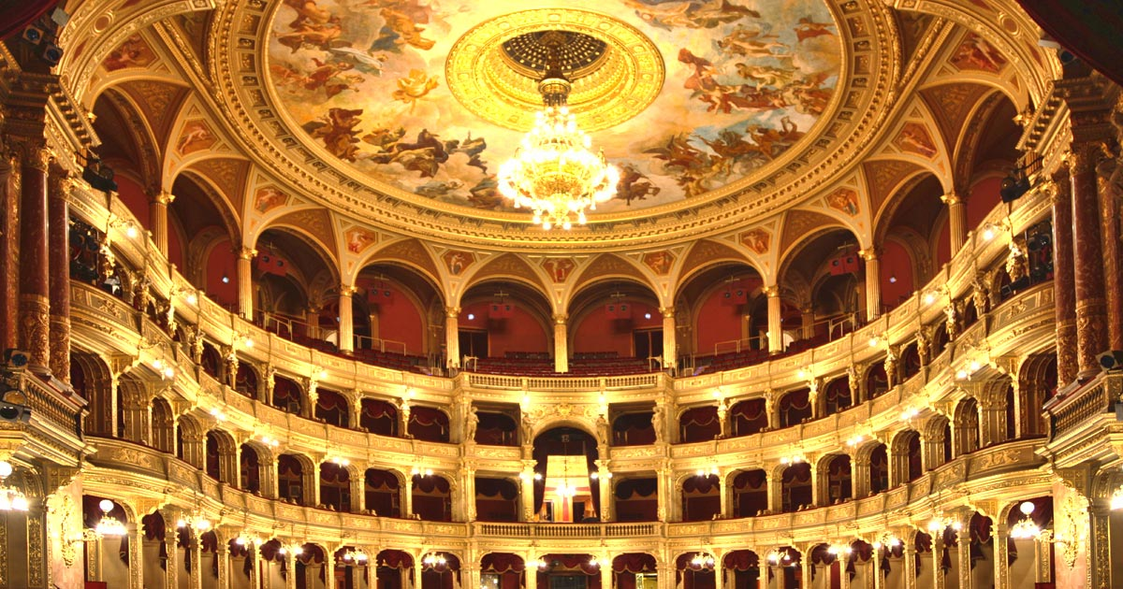

3 minutes walk to:

* + **Book Café – Lotz Terem**

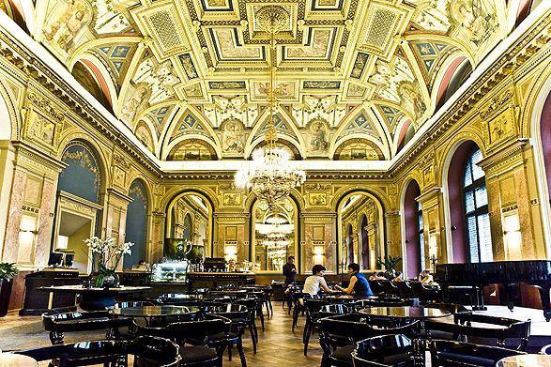

3 minutes walk to:

Lunch at around 2 pm: Restaurant: Ket Szerecsen, Nagymező utca 14, Budapest, 1065

**3 - 5 PM:**

Oktogon station: take Metro 1 to Deak Ferenc Ter

* **Deak Ferenc ter** has restaurants, cafes and the fashion street Deak Ferenc street

8 minutes walk

* **Dohány Synagogue (optional)**

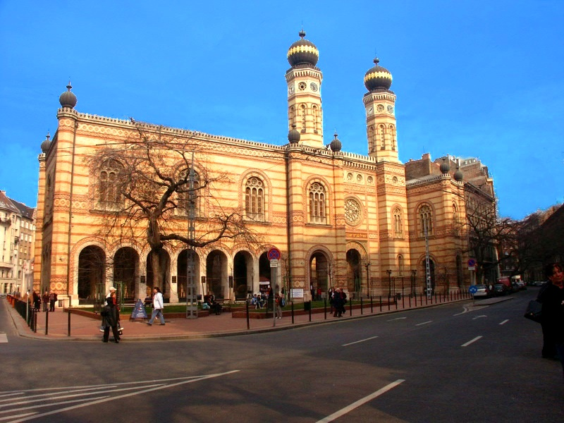

* **Vorosmartyi ter**
* **Walk along the river for sightseeing**

Shopping and walk around until 5 pm

Go home via public transport or parents will pick us up for dinner.

Dinner at 6 pm: Chinese restaurant

After dinner: **Gellért Hill** for nightview of the Danube and Budapest 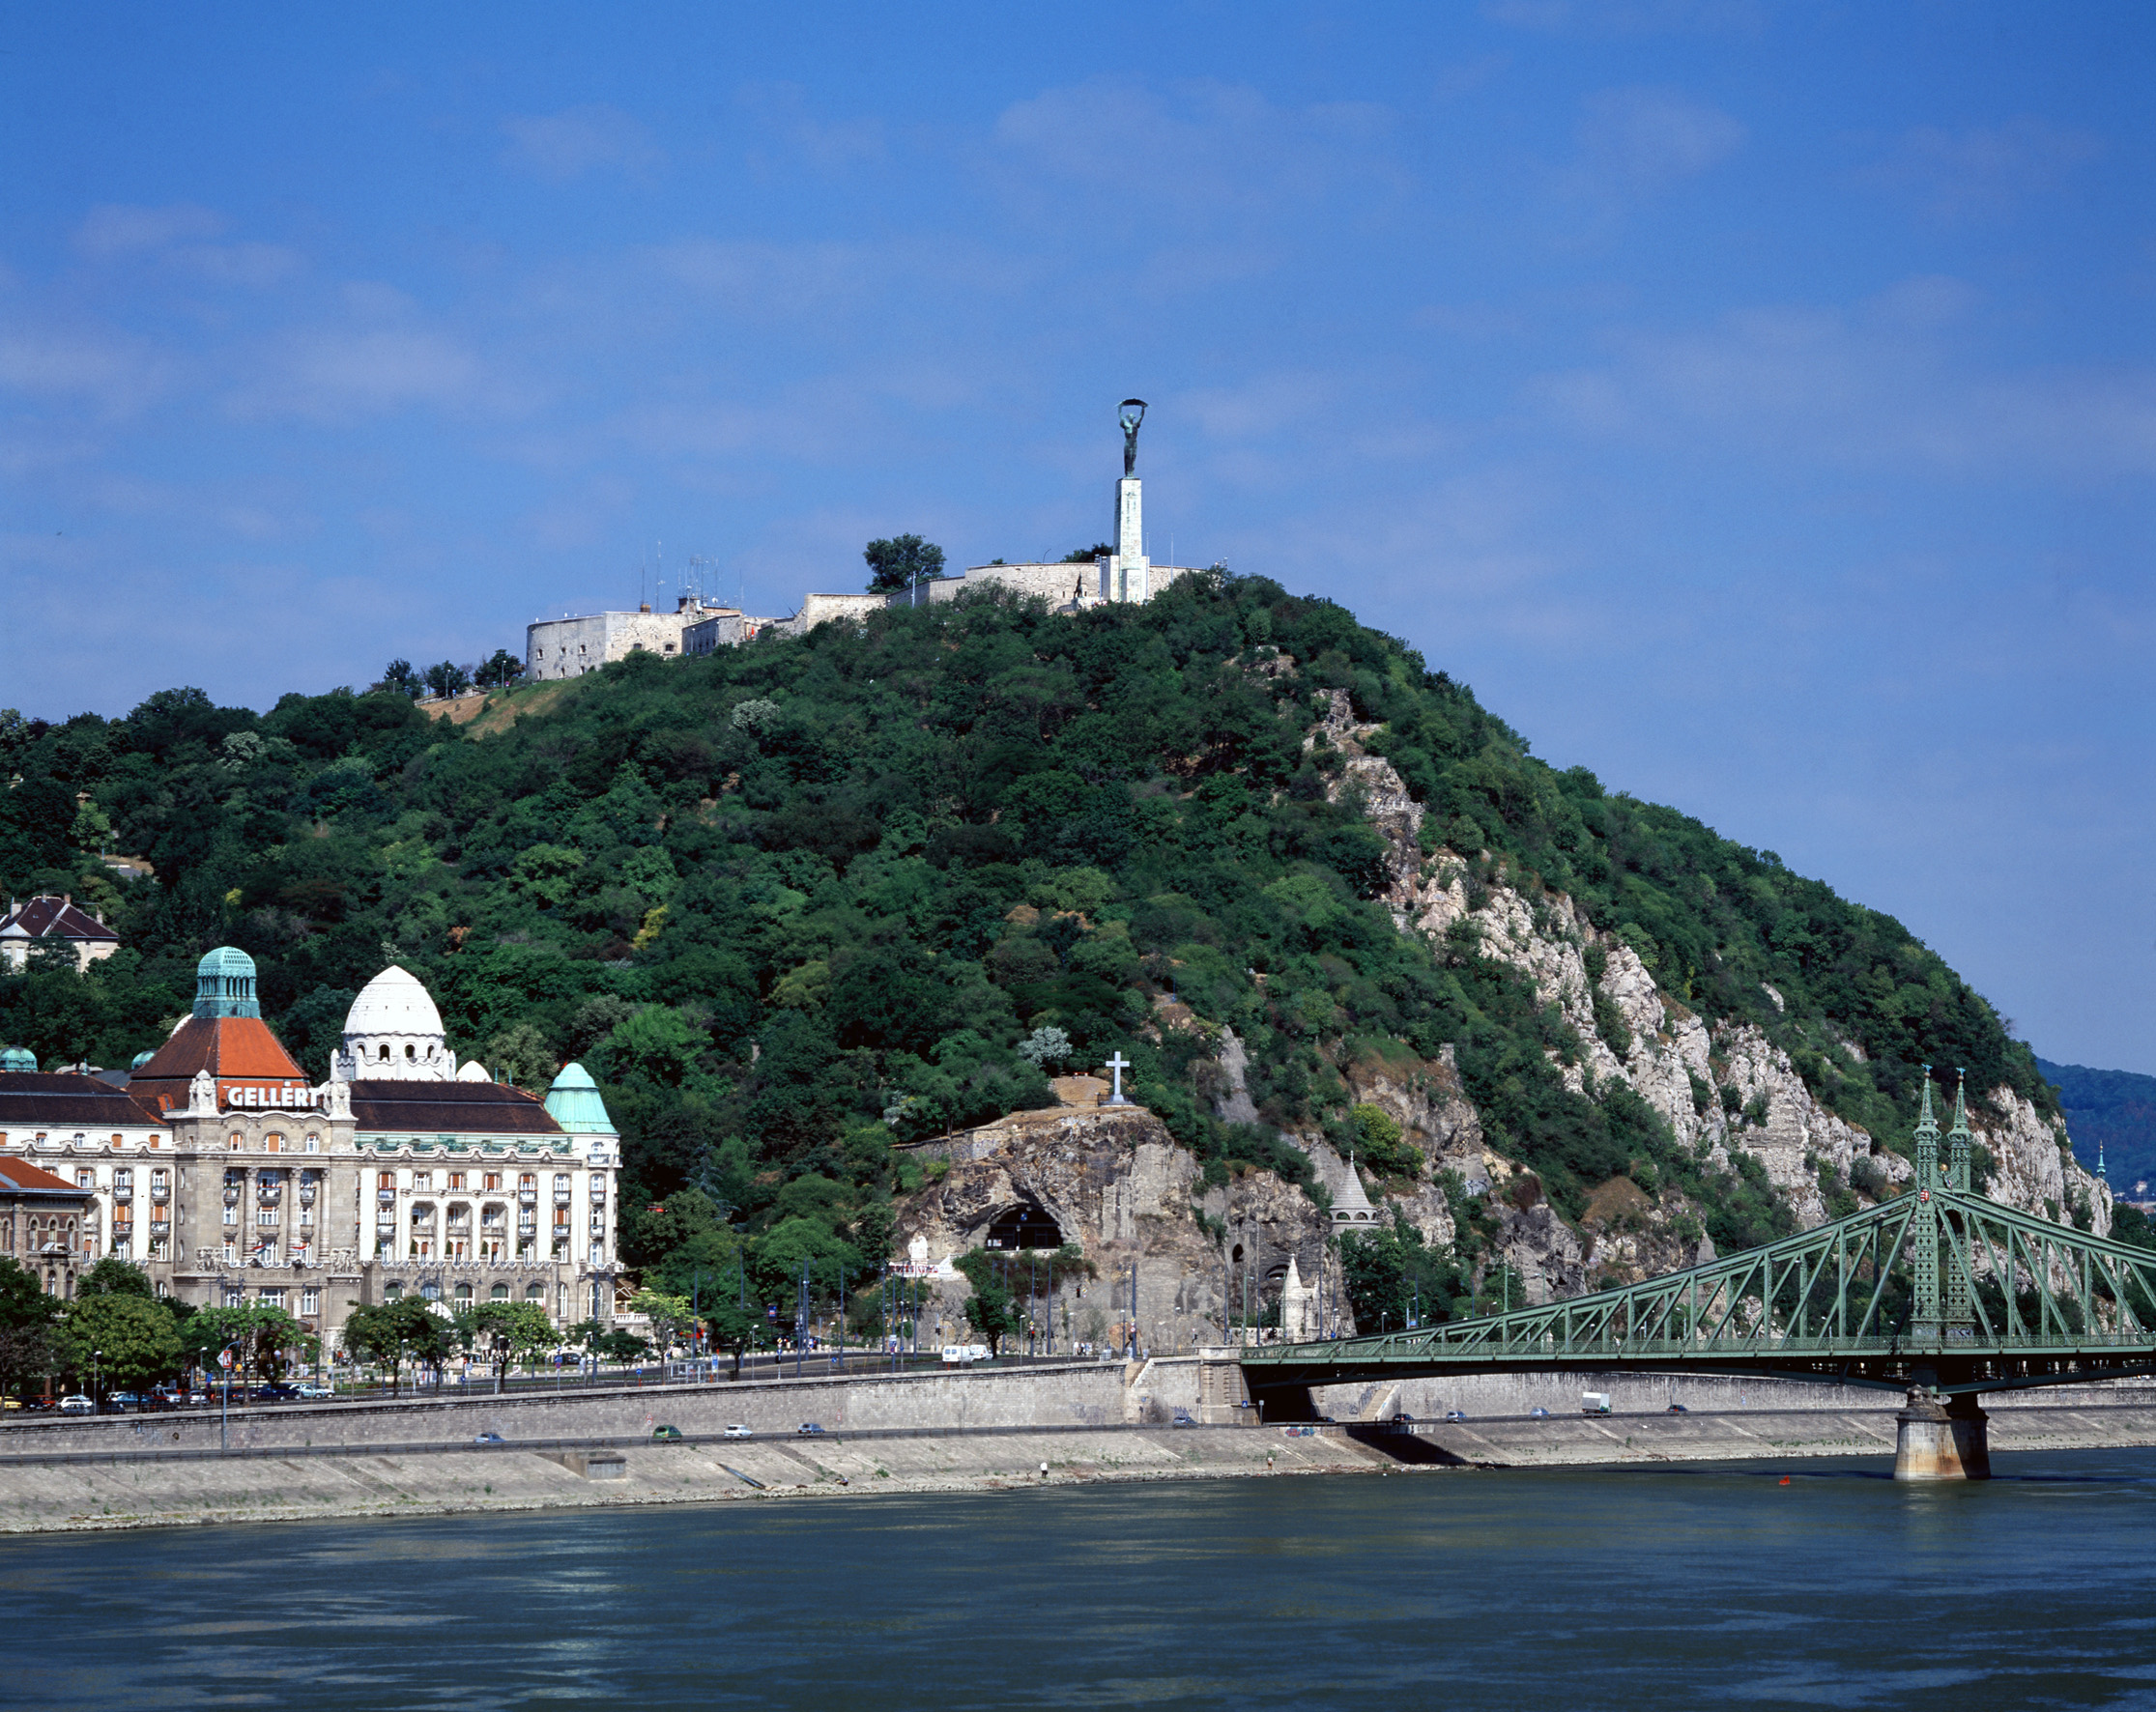

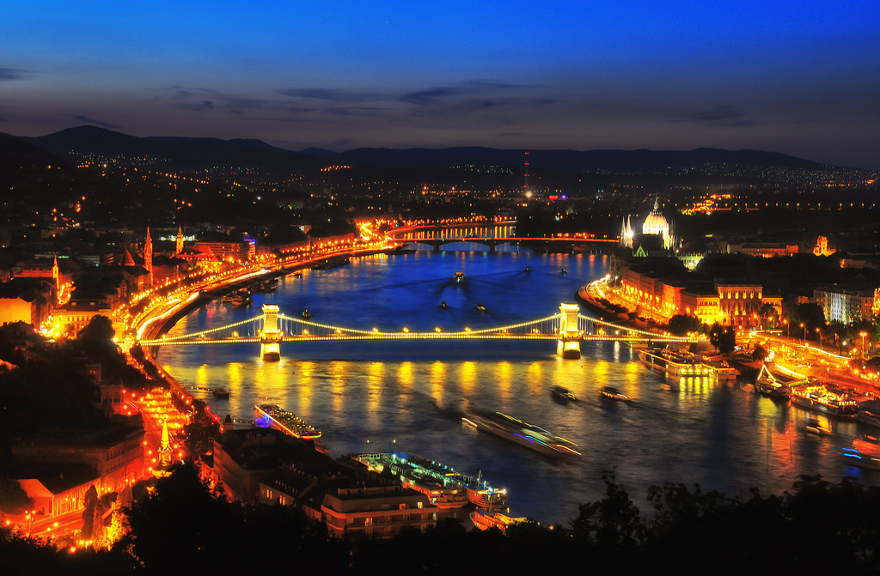

**Day 3, Saturday 30th July, Budapest**

Breakfast: at home

Leave at 9AM

**9AM - 1PM**

* Take bus 91 to go through **Margit bridge**---option to walk around **Margit Island** on the way
* Option to shop in **Westend City** (largest mall) which is next to one of the train stations in Budapest: **Nyugati Palyaudvar**

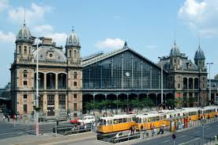

* The **City Park** (Varosliget) is Budapest's green lung and a popular spot for a stroll, with the **Vajdahunyad Castle** as the highlight. The romantic turreted building is actually inspired by the castle of the same name in Transylvania.
  + **Hero’s Square:** Heroes' Square sits right up between the City Park and Andrassy Avenue. It's one of Budapest's most visited sites and an optimal place to snap a photo. Take a look at the statues of Hungarian kings up along the colonnades!

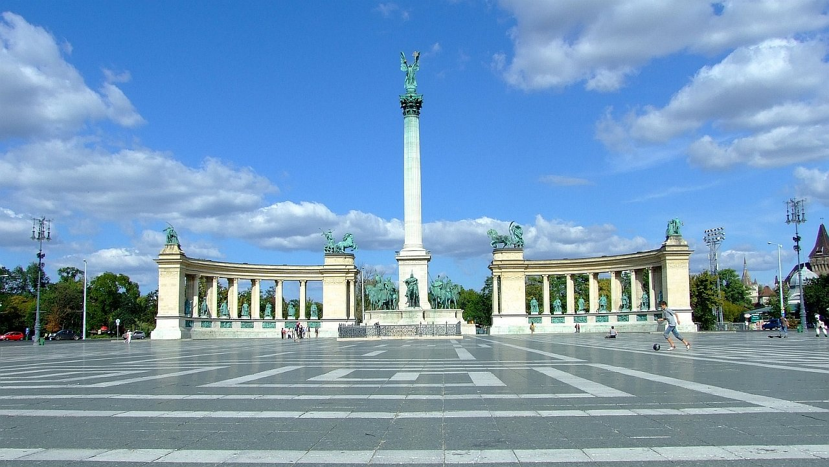

* + Budapest Zoo, Budapest Circus, **Szecheny Thermal Bath** are all around there
  + Option to canoe

Lunch: Városliget Café & Restaurant 1895 (numerous restaurants to choose from)

**2 - 3PM**

Metro 1 from Hosok Tere 🡺 Vorosmartyi utca: 8 minutes

* **House of Terror Museum (opens at 10AM-6PM Tue to Sunday)**

located at [Andrássy út](https://en.wikipedia.org/wiki/Andr%C3%A1ssy_Avenue) 60 in [Budapest](https://en.wikipedia.org/wiki/Budapest), [Hungary](https://en.wikipedia.org/wiki/Hungary). It contains exhibits related to the [fascist](https://en.wikipedia.org/wiki/Government_of_National_Unity_%28Hungary%29) and [communist](https://en.wikipedia.org/wiki/People%27s_Republic_of_Hungary) regimes in 20th-century Hungary and is also a memorial to the victims of these regimes, including those detained, interrogated, tortured or killed in the building.

(Ticket: 2000 Ft for an adult)

* **Liszt Ferenc Museum:** [**http://www.lisztmuseum.hu/en/**](http://www.lisztmuseum.hu/en/)(1500 Ft for adults)

|  |  |
| --- | --- |
| **Open:** | |
| Mo - Fr: | 10 - 18 |
| Saturday: | 09 - 17 |

**Dinner: TBD**

9pm: Late night: **Sightseeing on the Danube**

<https://www.tripadvisor.com/Attraction_Review-g274887-d1532337-Reviews-Legenda_Sightseeing_Boats-Budapest_Central_Hungary.html>

**Day 4, Sunday 31st July, Budapest**

* Caving: **Szemlohegyi Barlang**(option)： **Kedd kivételével minden nap,  
  10.00 – 16.00 óráig.**
* Margit Island (option)

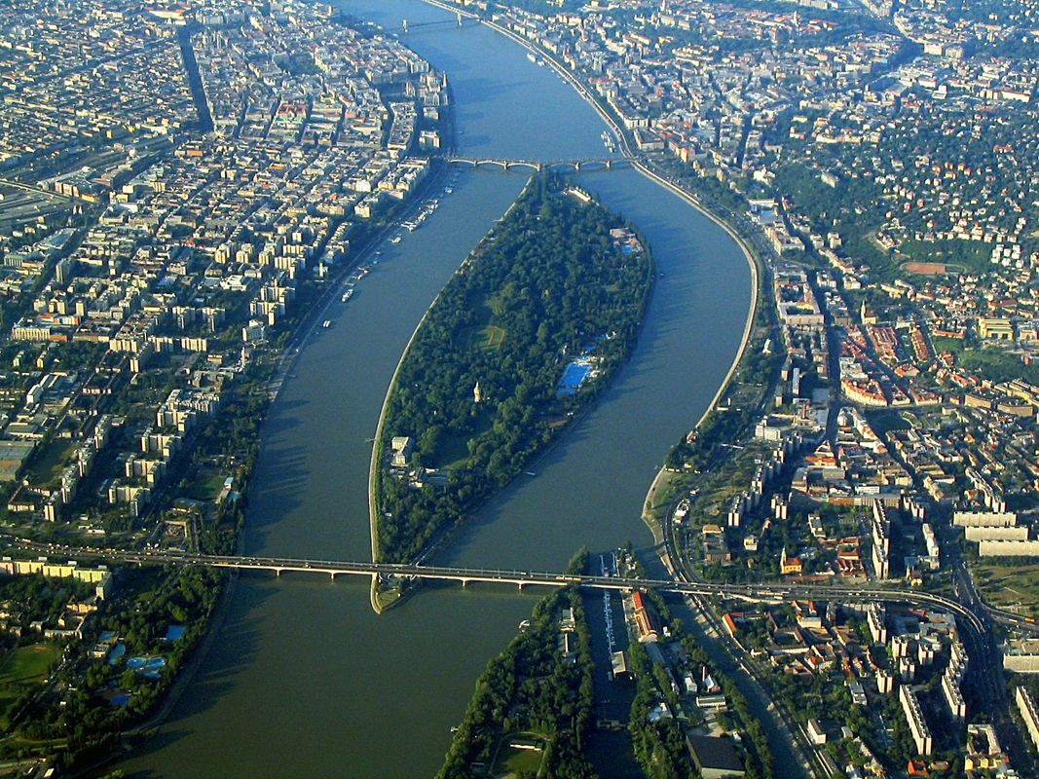

* **New York Café**

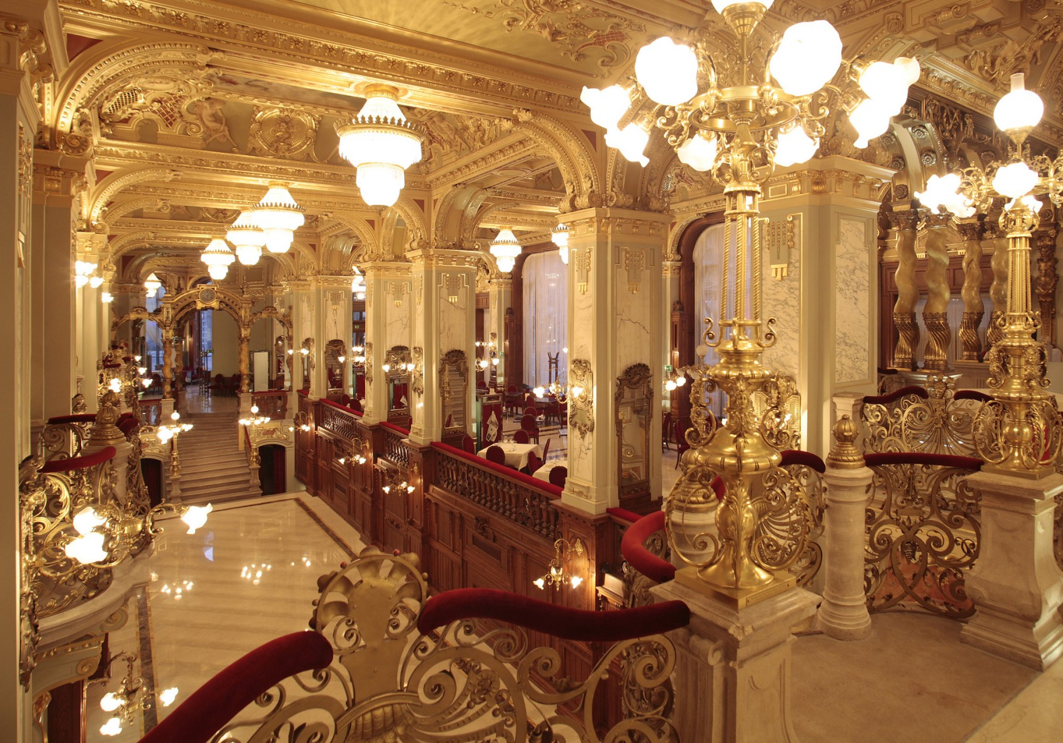

14 minutes with 4/6 traim

* **Holocaust Memorial Center**

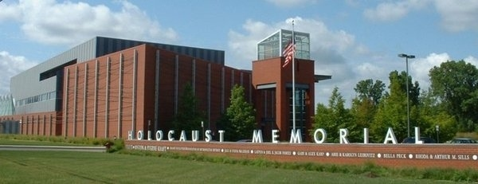

* **Rudas Thermal Bath:** [**http://www.rudasbaths.com/**](http://www.rudasbaths.com/)

**or**

* **Gellert Thermal Bath:** [**http://www.gellertbath.com/**](http://www.gellertbath.com/)

**Day 5, Monday 1st August, Vienna**

Vienna is known for its high quality of life. In a 2005 study of 127 world cities, the Economist Intelligence Unit ranked the city first (in a tie with Vancouver, Canada and San Francisco, US) for the world's most livable cities. Between 2011 and 2015, Vienna was ranked second, behind Melbourne, Australia. For seven consecutive years (2009–2015), the human-resource-consulting firm Mercer ranked Vienna first in its annual "Quality of Living" survey of hundreds of cities around the world, a title the city still holds in 2015. Monocle's 2015 "Quality of Life Survey" ranked Vienna second on a list of the top 25 cities in the world "to make a base within."

The UN-Habitat has classified Vienna as being the most prosperous city in the world in 2012/2013. The city was ranked 1st globally for its culture of innovation in 2007 and 2008, and sixth globally (out of 256 cities) in the 2014 Innovation Cities Index, which analyzed 162 indicators in covering three areas: culture, infrastructure, and markets. Vienna regularly hosts urban planning conferences and is often used as a case study by urban planners.

Between 2005 and 2010, Vienna was the world's number-one destination for international congresses and conventions. It attracts over 3.7 million tourists a year.

* 2:40 minutes travel time from Budapest to Vienna by train
* Arrive by noon
* Hotel: ????

Got these from tripadvisor:

2 days: <https://www.tripadvisor.com/ShowTopic-g190454-i147-k2029899-Vienna_For_2_Days-Vienna.html>

3 days in Vienna: <https://www.tripadvisor.com/Guide-g190454-k462-Vienna.html>

**Ringstrasse(optional)**

Vienna's state boulevard girds the city center and is the perfect place to orient yourself. It stands in the place of the former city walls, which were torn down after the Napoleonic Wars. Take the Yellow Ring Tram for a 30-minute tour past beautiful buildings such as state museums, the Opera, Austrian Parliament, Vienna City Hall, and Stadtpark.

Plan to stay: Less than 1 hour

**Kaerntnerstrasse (13 minutes from hotel)**

Vienna's luxury shopping mile is part of the pedestrian area in the center, running between the **State Opera** and **St. Stephen's Cathedral**.

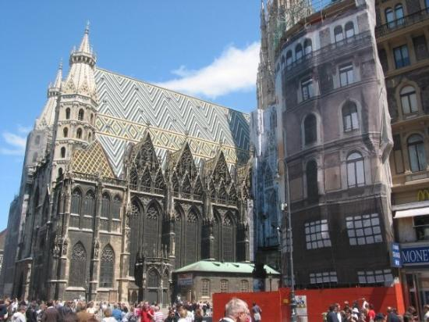

The most famous shops are Oesterreichische Werkstaetten and glass manufacturer **Lobmeyr Swarovski's stunning flagship store**. However, Kaerntnerstrasse is better for window shopping than souvenir shopping.

Plan to stay: Less than 1 hour

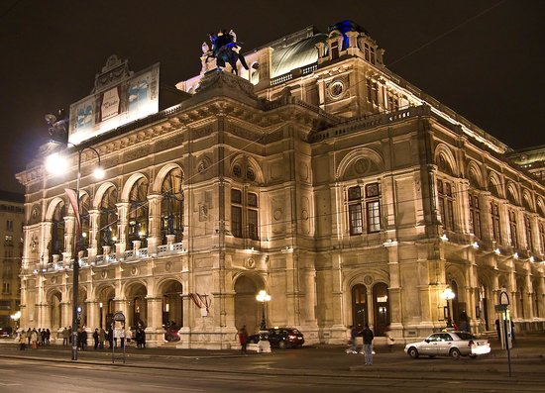

State Opera House

**Winterpalais (12 minutes)**

Winterpalais is a hidden gem of a town palace, and many travelers discover it by chance. It's located just off Kaerntnerstrasse and has only 10 rooms, so it won't overwhelm you on your first day. The palace once belonged to Prince Eugene of Savoy, one of Austria's most famous military commanders.

Plan to stay: Less than 1 hour

**MAK - Austrian Museum of Applied Arts / Contemporary Art (optional)**

Situated on Ringstrasse, the Museum of Applied Arts displays a wide array of Viennese arts and crafts, from 14th-century stained glass to 1950s figurines. Highlights include an excellent collection of Biedermeier sofas and Thonet chairs.

**Silberwirt (optional)**

If people ask me for a great insider place to have Austrian food, I often recommend Restaurant Silberwirt, for a variety of reasons. First, the menu covers the best of Austrian delicacies, including contemporary favorites. Second, the building complex, Schlossquadrat, dates from the 14th century and is a historic gem with a romantic courtyard. Finally, it's located off the beaten path in the trendy district of Margareten, popular with urban professionals and young families alike

**Day 6, Tuesday 2nd August, Vienna**

**Rathaus**

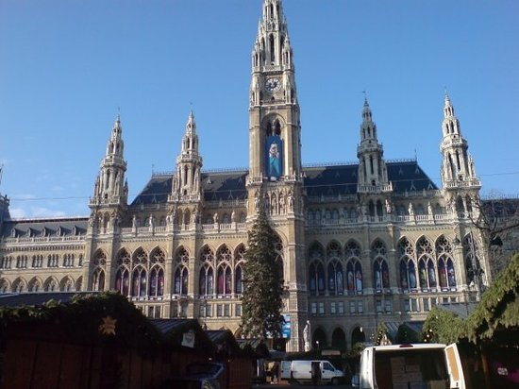

**Imperial Palace (Hofburg) (14 minutes)**

For six centuries, Vienna was the capital of the mighty Austro-Hungarian Empire, ruled by Habsburg dynasty. The Hofburg, home of the Habsburgs from the first emperor in 1273 until the last in 1918, grew in scope and grandeur over the years, as each emperor sought to outdo his predecessors. Today, it houses a cornucopia of attractions, including six museums, the National Library, and the Imperial Apartments. To get a feel for this place that was at the center of European history for hundreds of years, start in the middle and work your way out.

**Plan to stay:** 1-2 hours

* **Café Sacher**

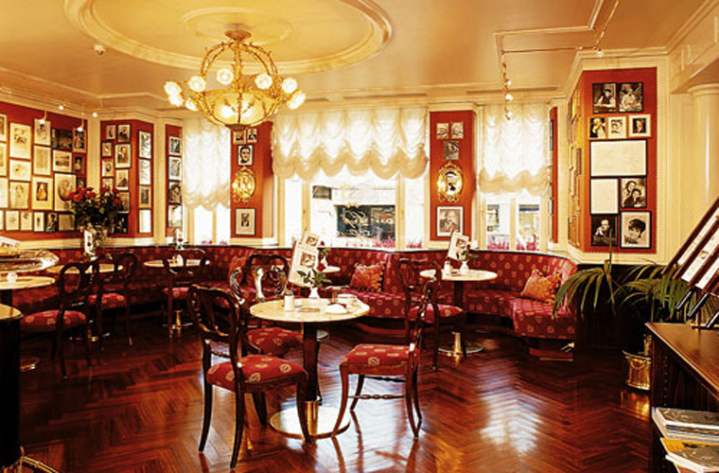

**Schoenbrunn Palace**

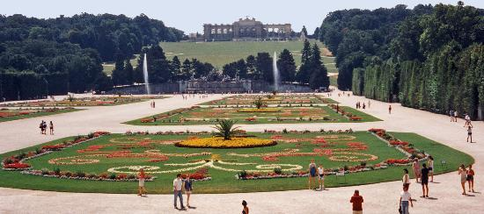

**Schonbrunner Garders**

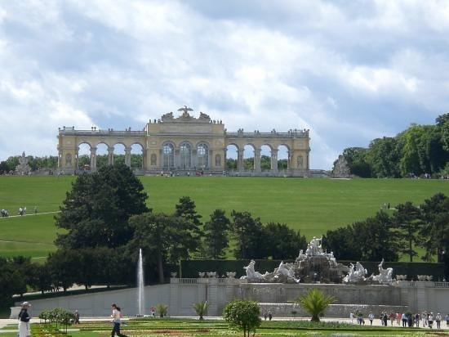

**Belvedere Palace Museum**

**Konditorei Heiner** is one of my favorite cake shops in the center of Vienna. You can go mad with cream cakes, gugelhupfs (bundt cakes), fruit tarts, pralines, cookies, waffles, and macaroons... You can also try the famed Sachertorte here. Heiner is a former supplier to the Imperial Court, but far less touristy than Demel, another former supplier. The cake shop has three different salons, including one upstairs.

Museumsquartier is Vienna's most exciting museum complex, housing more than 10 museums and cultural institutions. It's a great place to explore contemporary and 19th- and 20th-century art. Museumsquartier is located in the former Imperial stables, a beautiful baroque complex with a vast courtyard and funky lounge chairs that are perfect for relaxing

If you're always tempted to sneak behind private curtains, Hofzeile 27 is for you. For this private dining experience, Chef Sybille Fellner Kisler and her husband Wolfgang invite guests to their beautifully stylish townhouse in the leafy suburb of Doebling. The exquisite meals feature modern Austrian cuisine that can compete with top-quality Austrian restaurants. It's a fantastic way to explore contemporary urban living!

**Day 7, Wednesday 3rd August, Vienna --- Prague**

* Hotel: ????

**Cafe Museum**

Start your day with a Viennese breakfast at Cafe Museum, where Gustav Klimt used to take his coffee. I love the clean but cozy original 1930s feel: red velvet semi-circle benches, marble coffee tables, a fantastic selection of cakes and coffees, and very friendly service.

**Secession Building**

On your way to nearby Naschmarkt, you will pass the Secession Building, Vienna's key Art Nouveau landmark. Compare it to the city's Baroque buildings and you will understand the artistic revolution at the start of the 20th century, when Gustav Klimt and a number of his contemporaries 'seceded' from the conservative Künstlerhaus to found a new art association, (they commissioned the Secession Building as the exhibition space). Take the time to walk round the cubist architecture and to admire its signature globe of golden leaves.

**Naschmarkt** is Vienna's most popular food market, and the perfect hunting ground for all things vintage. Soak up the multicultural Balkan flair and try not to be bothered by the crowds! The green cast-iron stalls are almost 100 years old, and the whole market dates back to the 16th century.

**Plachutta Hietzing**

From Naschmarkt, take the Vienna U-Bahn Metro (U4 line) out to Hietzing for lunch in one of Vienna's most beautiful residential neighborhoods. Plachutta restaurants are well known for tafelspitz, a traditional boiled beef dish that became popular because it was one of Emperor Francis Joseph's favorites; while Plachutta has several busy outlets in the city center, Hietzing is more off the beaten track

From Hietzing, take one Metro station back to **Schoenbrunn Palace**, Vienna's number one attraction (and rightly so). The Habsburg Emperor's summer residence, with its richly decorated salons and beautiful garden compound, brings back Vienna's Imperial past in all its pomp and glory. In the warmer months, make the effort to climb up to Gloriette Belvedere for coffee, cakes, and a beautiful view of Schoenbrunn and the city.

Travel to Prague: 4 hours

Arrive in Prague in the evening.

Dinner:

**Day 8, Thursday 4th August, Prague**

Prague is home to a number of famous cultural attractions, many of which survived the violence and destruction of 20th-century Europe. Main attractions include the Prague Castle, the Charles Bridge, Old Town Square with the Prague astronomical clock, the Jewish Quarter, Petřín hill and Vyšehrad. Since 1992, the extensive historic centre of Prague has been included in the UNESCO list of World Heritage Sites.

**Tripadvisor 3 Days in Prague:** [**https://www.tripadvisor.com/Guide-g274707-k349-Prague_Bohemia.html**](https://www.tripadvisor.com/Guide-g274707-k349-Prague_Bohemia.html)

**Café Louvre**

This traditional café has a history spanning more than a hundred years, and its famous guests have included Franz Kafka, Karel Čapek and Albert Einstein. The café has preserved its ambiance, with a functionalist-style salon and a terrace, perfect in the summer, and here you can enjoy delicious food, an amazing interior and great service for a surprisingly low price.

**Palladium-Shopping mall in town center**

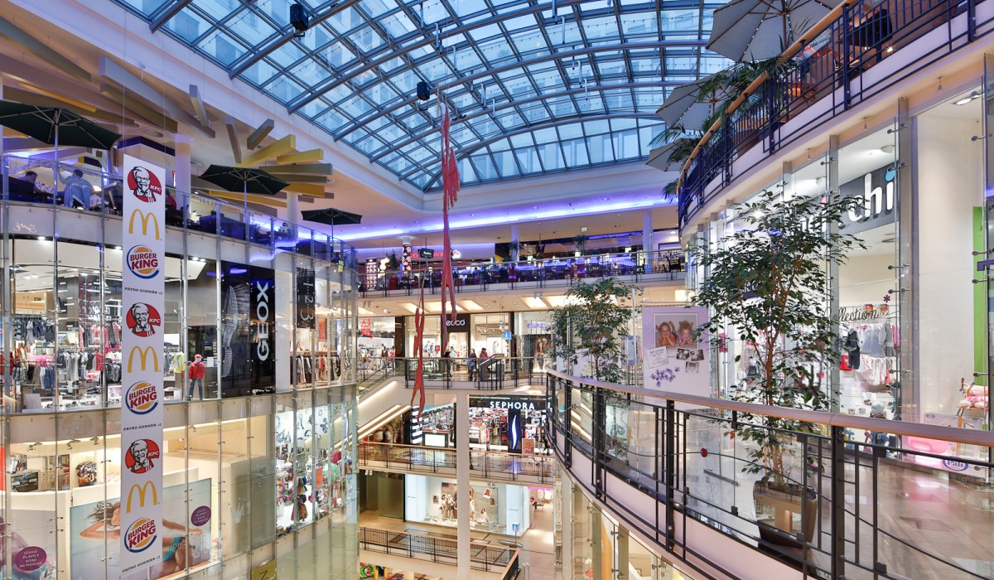

**Old Town Square**

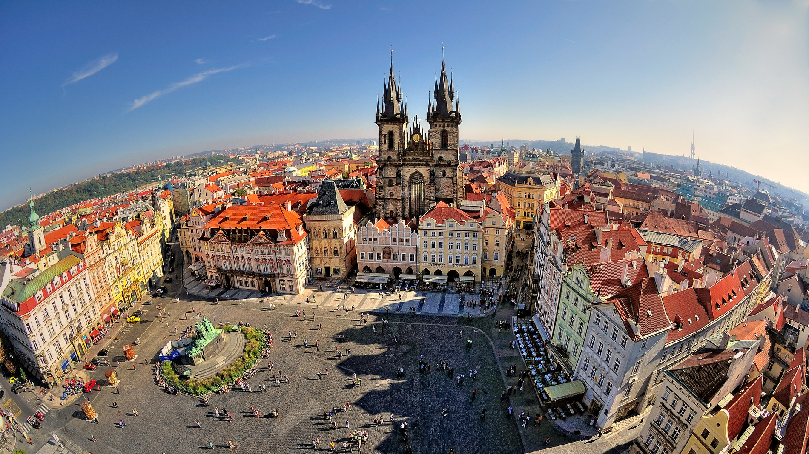

**Charles Bridge**

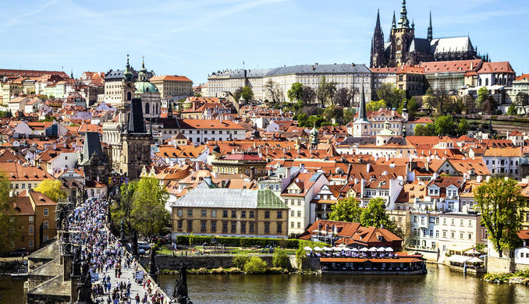

**Charles Bridge, Prague**

**Wenceslas Square**

With its art nouveau houses lining the almost 700 meter long boulevard, this is the cultural and shopping heart of Prague. The statue of Saint Vaclav is the famous meeting point where all the adventures start

* All three lines of the metro are within walking distance.
* The new National Museum building has an amazing cafe with delicious traditional snacks called "chlebíčky" — home baked bread with a tasty spread and vegetables.

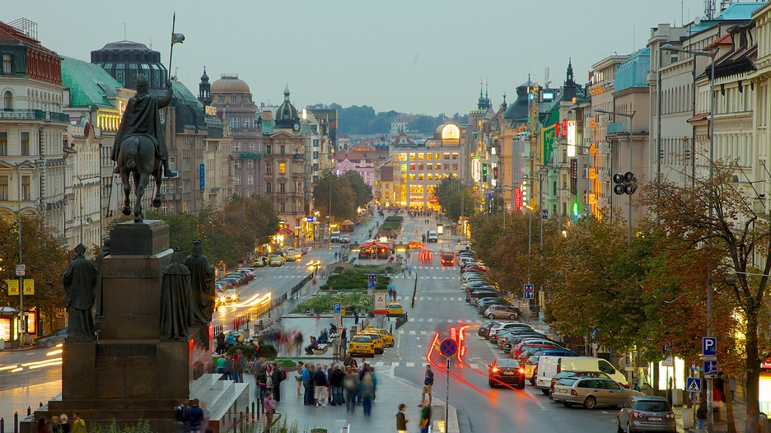

**Day 9, Friday 5th August, Prague**

**Prague Castle**

* I recommend taking tram #22 up the hill above Prague Castle (stop: Pohořelec). It is easier to enjoy the beauty of the area going down the hill rather than up.
* Take your time and explore the whole area. The gardens (open April through October) are beautiful and a great place to relax before the stroll down to the Malá Strana quarter.
* There are several types of tickets, including family discounts. All tickets are valid for two days. You can purchase the tickets online or on the spot.
* If you are on a budget trip, you can walk through the castle area for free (including Saint Vitus Cathedral). Golden Lane is free only in the evening.
* The ceremonial rotation of soldiers starts every day at noon and rotation at the observation posts occurs every hour, on the hour.

Plan to stay: 2-3 hours

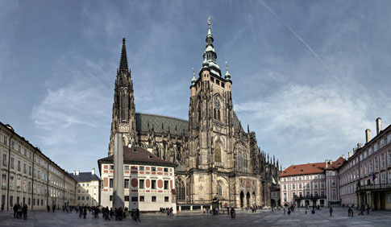

**Museum Kampa**

Originally a mill by the river and nowadays a neat little art space and home to a unique collection of modern Central European Art. If you love work by František Kupka, this place is a heaven.

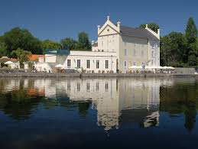

**National Theater**

Visiting the National Theater is a true cultural and artistic experience, and not only for the performance you are about to see, but because it represents the Czech will for independence. After the fire in the second half of the 19th century, the Czechs collected money for its renovation. And the result is beautiful: Golden rooftops, an amazing interior with paintings by Mikoláš Aleš and a curtain painted by Vojtěch Hynais.

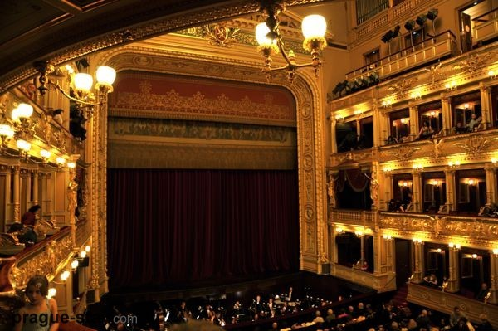

**Day 10, Saturday 6th August, Prague---Budapest**

7 hours 30 min travel back Budapest

OR

Stay one more day in Prague or in Vienna?

**Day 11, Sunday 7th August, Budapest**

**Lake Balaton or Szentendre-Esztergomb???**

**Lake Balaton** ([German](https://en.wikipedia.org/wiki/German_language): *Plattensee*) is a [freshwater](https://en.wikipedia.org/wiki/Freshwater) lake in the [Transdanubian](https://en.wikipedia.org/wiki/Transdanubia) region of [Hungary](https://en.wikipedia.org/wiki/Hungary). It is the [largest lake](https://en.wikipedia.org/wiki/List_of_largest_lakes_of_Europe) in [Central Europe](https://en.wikipedia.org/wiki/Central_Europe),[[2]](https://en.wikipedia.org/wiki/Lake_Balaton#cite_note-2) and one of the region's foremost tourist destinations. The [Zala River](https://en.wikipedia.org/wiki/Zala_River) provides the largest inflow of water to the lake, and the canalised [Sió](https://en.wikipedia.org/wiki/Si%C3%B3) is the only outflow.

The mountainous region of the northern shore is known both for its [historic](https://en.wikipedia.org/wiki/Transdanubia#History) character and as a major [wine region](https://en.wikipedia.org/wiki/Hungarian_wine), while the flat southern shore is known for its [resort towns](https://en.wikipedia.org/wiki/Resort_town). [Balatonfüred](https://en.wikipedia.org/wiki/Balatonf%C3%BCred) and [Hévíz](https://en.wikipedia.org/wiki/H%C3%A9v%C3%ADz) developed early as resorts for the wealthy, but it was not until the late 19th century when landowners, ruined by [*Phylloxera*](https://en.wikipedia.org/wiki/Phylloxera) attacking their [grape vines](https://en.wikipedia.org/wiki/Grape_vine), began building summer homes to rent out to the burgeoning middle classes.[[3]](https://en.wikipedia.org/wiki/Lake_Balaton#cite_note-3)

**Szentendre** is a riverside town in [Pest county](https://en.wikipedia.org/wiki/Pest_county), [Hungary](https://en.wikipedia.org/wiki/Hungary), near the capital city [Budapest](https://en.wikipedia.org/wiki/Budapest). It is known for its museums (most notably the Open-Air Ethnographic Museum), galleries, and artists.

[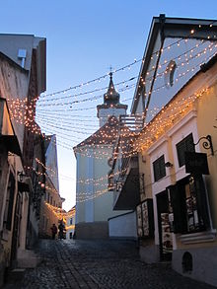](https://en.wikipedia.org/wiki/File:Szentendre11.JPG)

Town centre in January

Due to its historic architecture and easy rail and river access, it has become a popular destination for tourists staying in Budapest. There are many facilities, including [souvenir](https://en.wikipedia.org/wiki/Souvenir) shops and restaurants, catering to these visitors.

**Esztergom** (Hungarian pronunciation: [[ˈɛstɛrɡom]](https://en.wikipedia.org/wiki/Help:IPA_for_Hungarian) [](https://en.wikipedia.org/wiki/File:Hu-Esztergom.ogg) [listen](https://upload.wikimedia.org/wikipedia/commons/7/73/Hu-Esztergom.ogg) ([help](https://en.wikipedia.org/wiki/Wikipedia:Media_help)·[info](https://en.wikipedia.org/wiki/File:Hu-Esztergom.ogg)), also known by [alternative names](https://en.wikipedia.org/wiki/Names_of_European_cities_in_different_languages:_E%E2%80%93H#E)), is a [city](https://en.wikipedia.org/wiki/City) in northern [Hungary](https://en.wikipedia.org/wiki/Hungary), 46 kilometres (29 miles) northwest of the [capital](https://en.wikipedia.org/wiki/Capital_%28political%29) [Budapest](https://en.wikipedia.org/wiki/Budapest). It lies in [Komárom-Esztergom](https://en.wikipedia.org/wiki/Kom%C3%A1rom-Esztergom) [county](https://en.wikipedia.org/wiki/County), on the right bank of the [river](https://en.wikipedia.org/wiki/River) [Danube](https://en.wikipedia.org/wiki/Danube), which forms the border with [Slovakia](https://en.wikipedia.org/wiki/Slovakia) there.

Esztergom was the [capital of Hungary](https://en.wikipedia.org/wiki/Capitals_of_Hungary) from the 10th till the mid-13th century when King [Béla IV of Hungary](https://en.wikipedia.org/wiki/B%C3%A9la_IV_of_Hungary) moved the royal seat to [Buda](https://en.wikipedia.org/wiki/Buda).

Esztergom is the seat of the *prímás* (see [Primate](https://en.wikipedia.org/wiki/Primate_%28bishop%29)) of the [Roman Catholic Church](https://en.wikipedia.org/wiki/Roman_Catholic_Church) in Hungary, and the former seat of the [Constitutional Court of Hungary](https://en.wikipedia.org/wiki/Constitutional_Court_of_Hungary). The city has the [Keresztény Múzeum](https://en.wikipedia.org/wiki/Kereszt%C3%A9ny_M%C3%BAzeum), the largest [ecclesiastical](https://en.wikipedia.org/wiki/Ecclesiastical) collection in Hungary. Its [cathedral](https://en.wikipedia.org/wiki/Cathedral), [Esztergom Basilica](https://en.wikipedia.org/wiki/Esztergom_Basilica) is the largest church in Hungary.

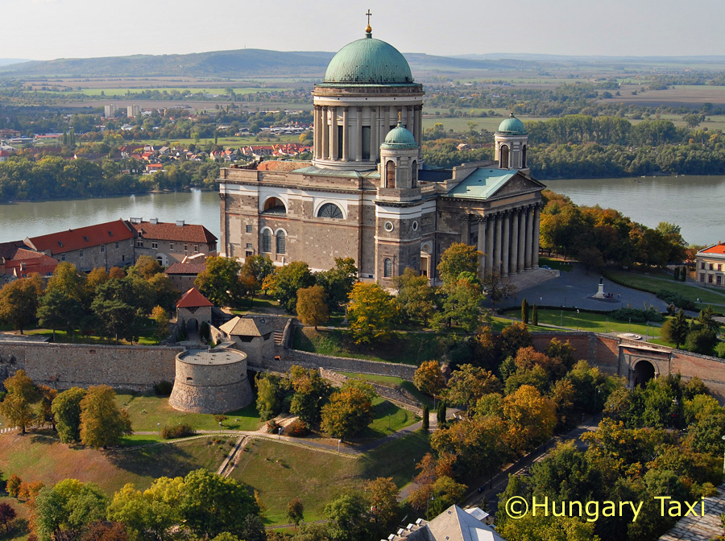

The site would host the upcoming 52nd [International Eucharistic Congress](https://en.wikipedia.org/wiki/International_Eucharistic_Congress) in 2020.

**Rudas Thermal Bath:** [**http://www.rudasbaths.com/**](http://www.rudasbaths.com/)

**or**

**Gellert Thermal Bath:** [**http://www.gellertbath.com/**](http://www.gellertbath.com/)

**Day 12, Monday 8th August, Budapest**

Győr

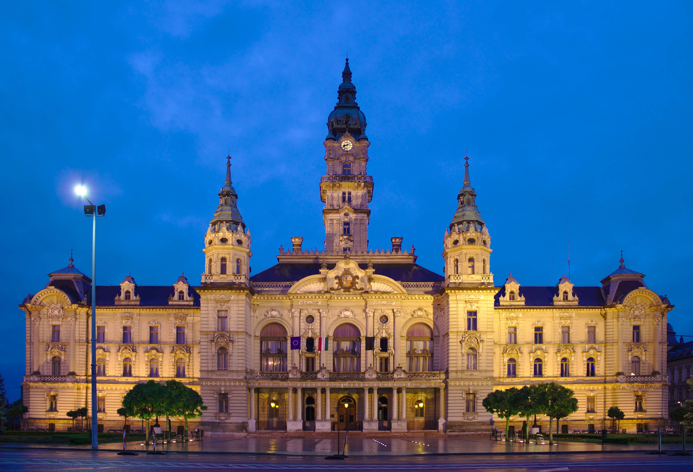

**Day 13, Tuesday 9th August, Budapest**

Shopping at Pandorf Outlet, Austria

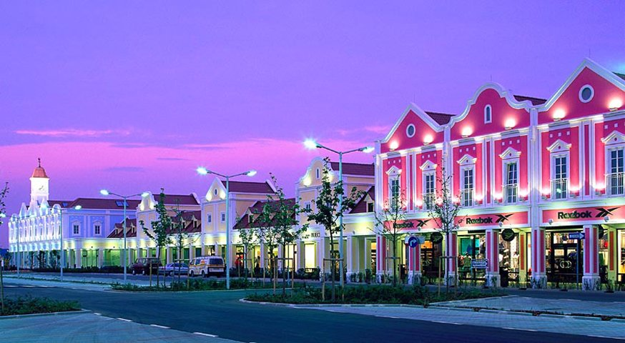

Pack

**Day 14, Wednesday 10th August, Budapest**

Leaves early morning at 6:30am

**Tull an der Donau (44 km, 40 min drive from Vienna by train)**